**Learners have to come up with a Report to support the answers to the following questions and suggestions**

**Objective Questions:**

1. What is the distribution of account balances across different regions?

**Answer:** The SQL query computes the distribution of account balances across    different regions by joining table’s customer info, geography, and churn. It calculates the total balance, average balance, maximum balance, and minimum balance for each region. The results reveal the distribution of account balances for France, Spain, and Germany, showcasing their total balances, average balances, maximum balances, and minimum balances.

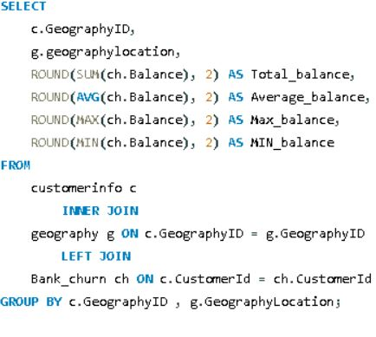

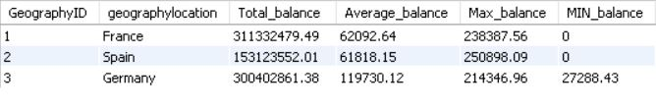

**Location- Obj-1 page of power bi**

1. Identify the top 5 customers with the highest Estimated Salary in the last quarter of the year. (SQL)

**Answer-**

* The top 5 customers with the highest estimated salary in the last quarter of the year. The results of the query in a table that includes the Customer ID, Surname, and Highest salary.
* the customer with the highest estimated salary is Dyer, with a salary of $199,970.74. The other customers in the top 5 are Oluchukwu ($199,841.32), Mai ($199,805.63), Palerma ($199,753.97), and Dimauro ($199,638.56).

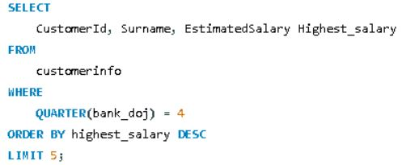

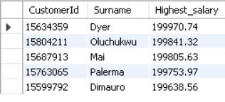

* **Conclusion:**
* It is important to note that this is just an estimate of salary, and the actual salaries of these customers may be higher or lower. Additionally, the data only includes information for the last quarter of the year

1. Calculate the average number of products used by customers who have a credit card. (SQL)

* The average number of products used by customers who have a credit card.
* The average number of products purchased by customers who have a credit card and the answer is 1.5314.
* 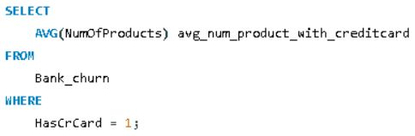

C:\Users\ncr\Pictures\Objective 3.JPG

1. Determine the churn rate by gender for the most recent year in the dataset.

**Answer:**

* The churn rate for females is 25.0488%, whereas the churn rate for males is 15.3716%.
* Overall, the churn rate for females is higher than the churn rate for males in the dataset you provided.

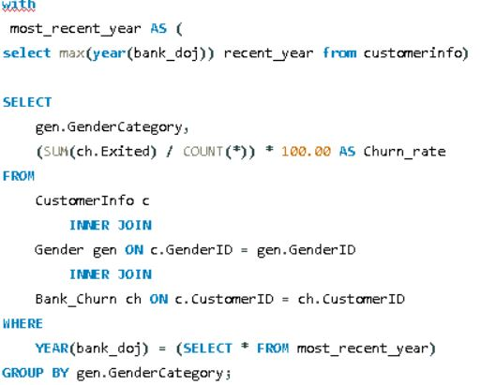

* 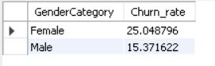

1. Compare the average credit score of customers who have exited and those who remain. (SQL)

**Answer:**

* The average credit score of customers who have exited and those who remain. The average credit score for exited customers is 645.35 and the average credit score for remaining customers is 651.85.
* **Conclusion**: the average credit score is slightly higher for customers who remain than for those who exited
* 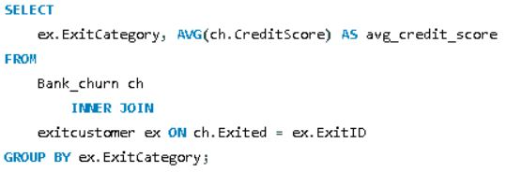

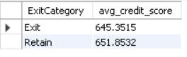

1. Which gender has a higher average estimated salary, and how does it relate to the number of active accounts? (SQL)

Answer:

* Females have a higher average estimated salary ($100,601.54) than males ($99,664.58) in this. However, the table also shows that there are more active accounts for males (2,867) than females (2,284).

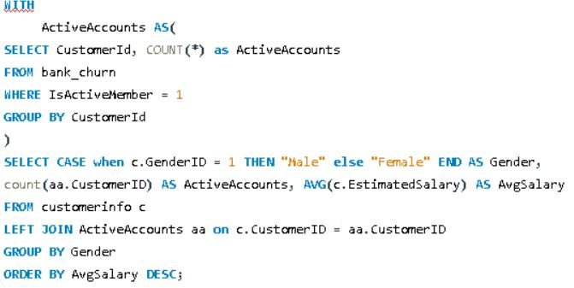

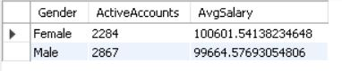

1. Segment the customers based on their credit score and identify the segment with the highest exit rate. (SQL)

**Answer**: **The exit rate for different credit score segments. The credit score segments are:**

* Excellent (>= 800 score)
* Very good (740-799 score)
* Good (670-739 score)
* Fair (580-669 score)
* Poor (< 580 score)
* The exit rate is highest for customers with poor credit scores (22.01%). This means that customers in this segment are more likely to churn than customers in other segments.

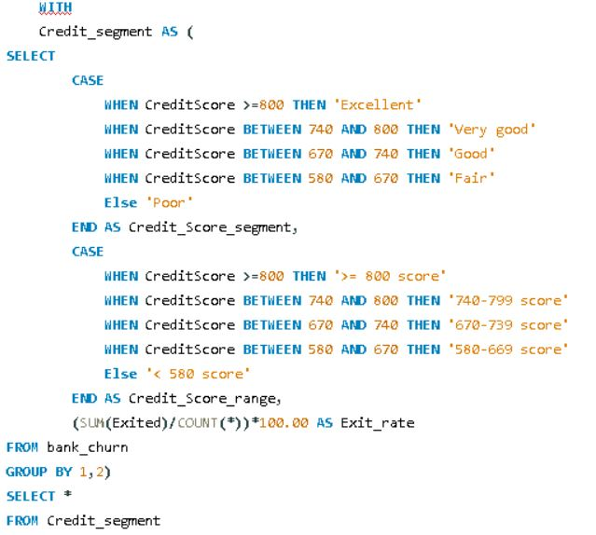

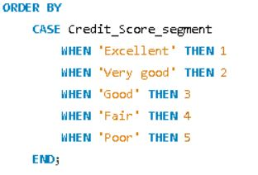

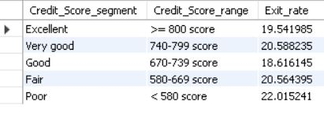

1. Find out which geographic region has the highest number of active customers with a tenure greater than 5 years. (SQL

**Answer:**

* The number of active customers with a tenure greater than 5 years for three different geographic regions. France has the highest number of active customers with 797, followed by Spain with 431 and Germany with 399.

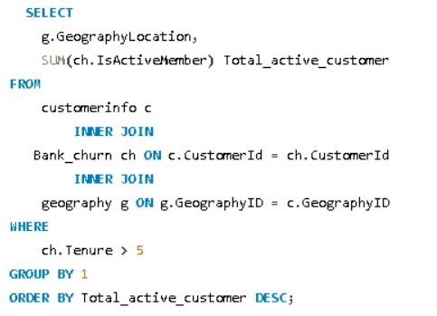

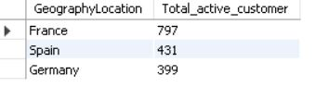

* **Conclusion**: France has the highest number of active customers with a tenure greater than 5 years.

1. What is the impact of having a credit card on customer churn, based on the available data?

**Answer:**

* Higher number of customers (6,000) have a credit card and did not exit (presumably did not churn), compared to the 1,424 who churned.
* There are also a significant number of customers (2,332) who don’t have a credit card and did not churn.
* There are also 613 customers who churned without having a credit card.

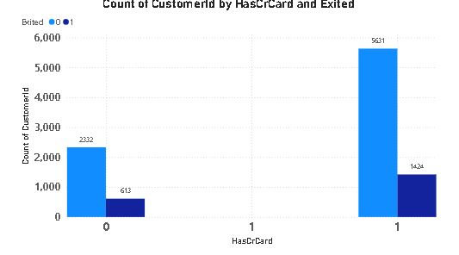

1. For customers who have exited, what is the most common number of products they have used?

**Answer:**

* This query calculates the frequency of each distinct number of products used by customers who have exited (Exited = 1). It then selects the number of products with the highest frequency, indicating the most common number of products used by exited customers.

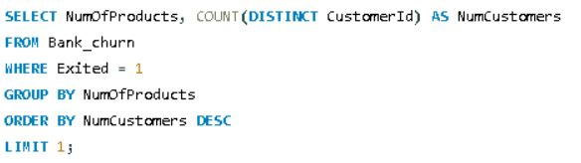

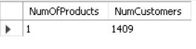

1. Examine the trend of customers joining over time and identify any seasonal patterns (yearly or monthly). Prepare the data through SQL and then visualize it.

**Answer:**

**The analysis of customer joining trends reveals a steady increase in customer acquisition over the years**

* The table has two columns: "Year" and "Total_customer". The years listed are 2016, 2017, 2018, and 2019. The number of customers for each year is listed beside it. In 2019, there were 3313 customers, the most out of the four years. In 2016, there were 1951 customers, the least out of the four years.
* The month with the most customers is November (Month 11) with a total of 1437 customers.
* December (Month 12) has the second most customers with 1409.
* There seems to be a seasonal trend, with the number of customers consistently dropping from November to June (Month 6) which has 765 customers.
* The lowest number of customers is in January (Month 1) with 482.

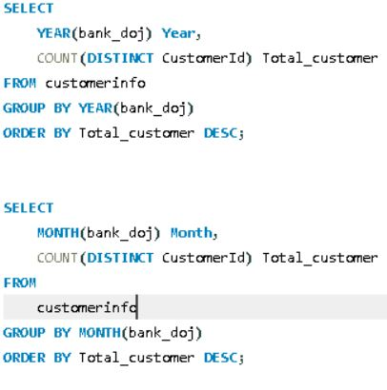

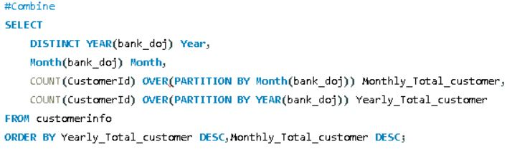

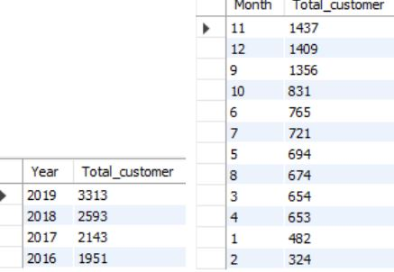

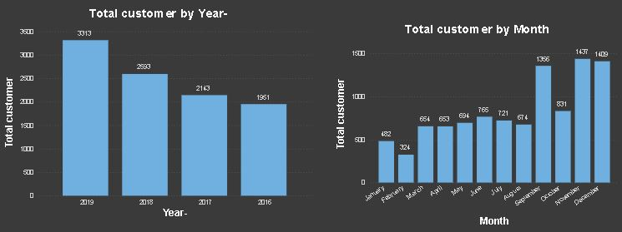

1. Analyze the relationship between the number of products and the account balance for customers who have exited.

**Answer**:

* The number of products ranges from 1 to 4.
* Customers with a balance of $93733.14 on average had 4 products.
* Customers with a balance of $92028.82 on average had 1 product.
* Customers with a balance of $90252.36 on average had 2 products.
* Customers with a balance of $85853.09 on average had 3 products.

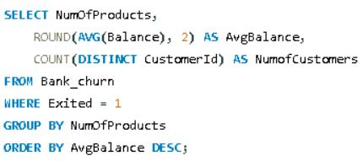

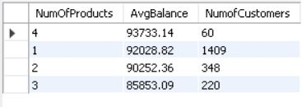

1. Identify any potential outliers in terms of balance among customers who have remained with the bank.

**Answer:**

Bar Chart (Total Customers by Balance Segment):

This bar chart segments customers into high balance, medium balance, and low balance categories.

A significantly larger number of customers fall into the high balance category, followed by low balance, and very few in the medium balance category.

* High balance segment: This segment has the most customers, with a count of approximately 6,308.
* Medium balance segment: This segment has a count of approximately 3,618.
* Low balance segment: This segment has the least number of customers, with a count of approximately 74.

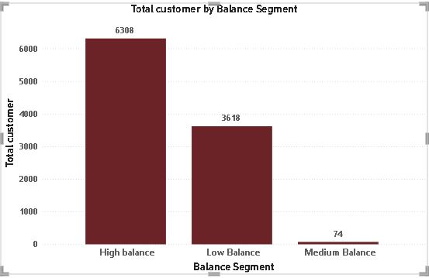

**Location obj-13 page of power bi**

1. How many different tables are given in the dataset, out of these tables which table only consists of categorical variables?

**Answer:**

Among the seven tables in the dataset, five exclusively contain categorical variables. The remaining two tables, "BankChurn" and "CustomerInfo", incorporate continuous variables. In the "BankChurn" table, examples of continuous variables include balance and the number of products held by the customer. Similarly, the "CustomerInfo" table contains the continuous variable estimated salary.

1. Using SQL, write a query to find out the gender-wise average income of males and females in each geography id. Also, rank the gender according to the average value. (SQL)

**Answer**:

* The average income for males and females in each geographic location and assigns a rank (1 being the highest) based on the average income within each location.
* This analysis provides valuable insights into income disparities across genders within different geographical contexts.

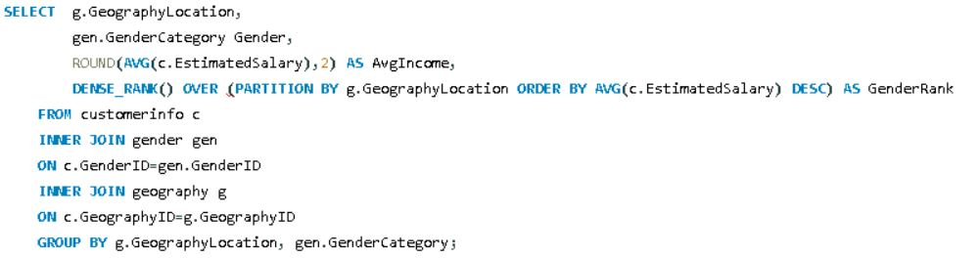

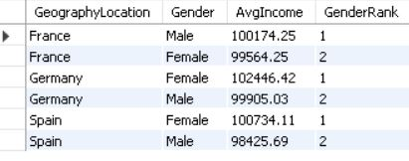

1. Using SQL, write a query to find out the average tenure of the people who have exited in each age bracket (18-30, 30-50, 50+).

**Answer**:

* This SQL query efficiently calculates the average tenure of customers who have exited within each age bracket (18-30, 30-50, 50+). By categorizing customers based on their ages and joining the necessary tables, it accurately computes the average tenure for each age group. The results provide valuable insights into the average tenure of churned customers across different age demographics.

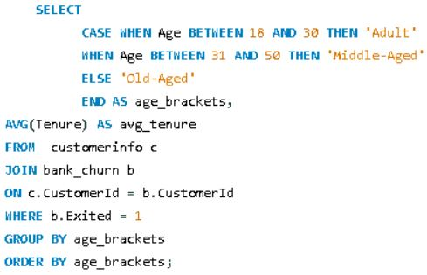

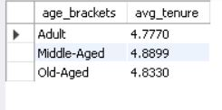

1. Is there any direct correlation between salary and the balance of the customers? And is it different for people who have exited or not?

**Answer:**

* There appears to be a positive correlation between the average balance and the estimated salary. This means that customers with a higher estimated salary tend to have a higher average balance.
* The data points are scattered around a general upward trend. This suggests that there is a relationship, but it is not a perfect one. There are many customers who deviate from the trend.

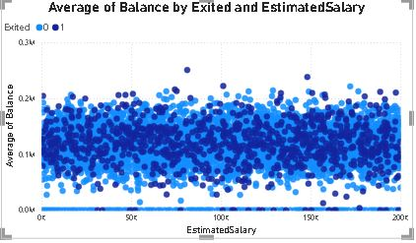

**Location – obj 17 page of power bi**

1. Is there any correlation between the salary and the Credit score of customers?

**Answer:** This SQL query calculates the correlation coefficient between the salary and credit score of customers. The resulting coefficient of -0.0014 suggests a very weak correlation between these two variables. In summary, there is minimal evidence to indicate a significant correlation between the salaries and credit score of customers.

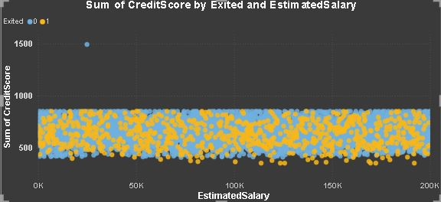

1. Rank each bucket of credit score as per the number of customers who have churned the bank.

* it appears to show the distribution of churned customers
* (Count on the y-axis) across different credit score segments (x-axis). Below is
* The formula that I have used to calculate Credit Score Segment.

CreditScoreSegment = IF(Bank_Churn[CreditScore]>=800,"Excellent",IF(Bank_Churn[CreditScore] >= 700,"Good",IF(Bank_Churn[CreditScore]>=600,"Not Bad",IF(Bank_Churn[CreditScore] >= 500,"Fair","Poor"))))

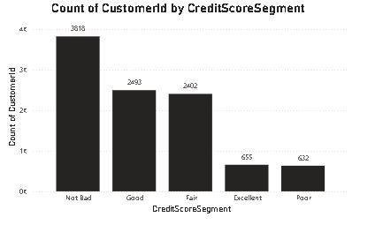

**Location- Obj- 19 Page of power bi**

1. According to the age buckets find the number of customers who have a credit card. Also retrieve those buckets that have lesser than average number of credit cards per bucket.

**Answer:**

* + Age Brackets: This column lists the different age groups of the customers. The age groups include Adult and Old Aged.
* Has Credit Card: This column shows the number of customers in each age bracket who have a credit card. There are 1400 Adults and 874 Old Aged customers who have a credit card based on the data provided.

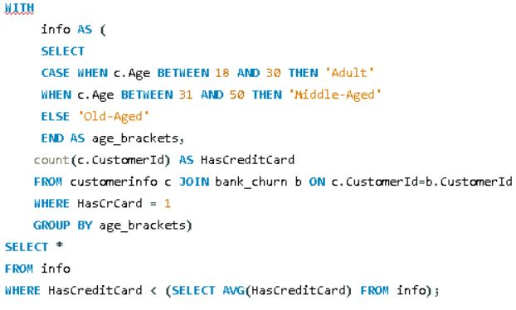

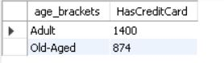

1. Rank the Locations as per the number of people who have churned the bank and average balance of the customers.

**Answer:**

* + GeographyLocation: This column lists the different geographic locations of the bank's customers. The locations include Germany, France, and Spain.
* num_exited: This column shows the number of customers who have churned (presumably exited the bank) in each location. The table shows that 814 customers churned in Germany, 810 in France, and 413 in Spain.
* avg_balance: This column shows the average balance maintained by the customers in each location. The average balance is highest in France at €15,692,615.64, followed by Germany at €15,688,703.87, and Spain at €15,687,680.94.

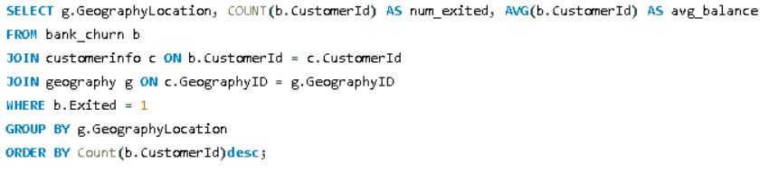

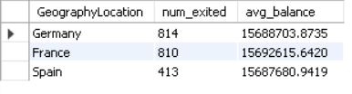

1. As we can see that the “CustomerInfo” table has the CustomerID and Surname, now if we have to join it with a table where the primary key is also a combination of CustomerID and Surname, come up with a column where the format is “CustomerID_Surname”.

 To create a new column named "CustomerID_Surname" as part of the result set from a join between the "CustomerInfo" table and another table, where the primary key is a combination of CustomerID and Surname, follow these steps:

**Answer:**

* Ensure Data Types:
  + Confirm that CustomerID in "CustomerInfo" is of a character data type or can be converted to one. Depending on the database system, the CONVERT function might not be necessary.
* Perform Join on Individual Columns:
  + Execute a join between the "CustomerInfo" table and the other table using separate columns for CustomerID and Surname, rather than a combined primary key.
* Create the New Column:
  + In the SELECT clause of your query, use the CONCAT function (or an equivalent function in your database system) to concatenate the CustomerID and Surname columns from "CustomerInfo," separated by an underscore ("_").

1. Without using “Join”, can we get the “ExitCategory” from ExitCustomers table to Bank_Churn table? If yes do this using SQL.
   * Retained Customers: 7963
   * Exited Customers: 2037

* This data helps in understanding the churn rate and retention of customers in the bank.



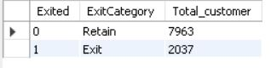

1. Were there any missing values in the data, using which tool did you replace them and what are the ways to handle them?

**Answer:**

* Missing values were identified in the active customers table and were removed using python. Data inconsistencies in the CustomerInfo table were also addressed:
* Special characters in the Surname column were cleaned using string manipulation functions.
* Data type errors were corrected:
  + Bank_DOJ column: Numeric values were converted to date format.
  + Age column: Numeric values were converted to text format.

1. Write the query to get the customer IDs, their last name, and whether they are active or not for the customers whose surname ends with “on”.

**Answer**- This query retrieves the customer IDs, last names, and their active status for customers whose surname ends with "on". It joins the customerinfo, churn, and activecustomer tables based on relevant keys and filters the results to include only those customers with surnames ending in "on".

* CustomerID: This column contains unique identifiers for each customer. The values include 15788218, 15750181, 15788448, and so on.
* Last Name: This column contains the customer's last name. The last names include Henderson, Sanderson, Watson, and so on.
* ActiveCategory: This column indicates whether the customer is an active member or an inactive member. The table shows that customer Henderson (CustomerID: 15788218) is an active member, while Sanderson (CustomerID: 15750181) is an inactive member, and so on.

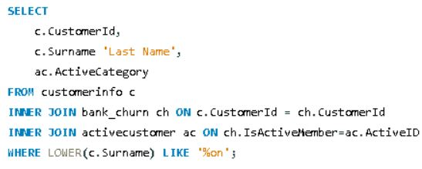

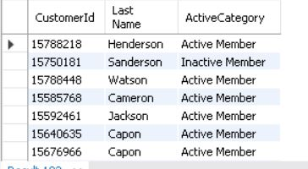

1. Can you observe any data disrupency in the Customer’s data? As a hint it’s present in the IsActiveMember and Exited columns. One more point to consider is that the data in the Exited Column is absolutely correct and accurate.

Yes, there is a data discrepancy observed in the Customer's data. Specifically, in the IsActiveMember and Exited columns, there are instances where customers who have exited are marked as active members. Upon examination, 735 rows were found where the exited customer is incorrectly labelled as active. To rectify this inconsistency, all instances of exited customers were marked as inactive members.

UPDATE Churn

SET IsActiveMember = 0

WHERE Exited = 1 AND IsActiveMember = 1;

**Subjective Question:**

1. Customer Behavior Analysis: What patterns can be observed in the spending habits of long-term customers compared to new customers, and what might these patterns suggest about customer loyalty?

* The graph shows that long-term customers tend to have higher average balances than new customers. We use two charts to show about the customer loyalty In first chart we use average of balance by month and customer status. And in the second chart we use salary segment along with status.

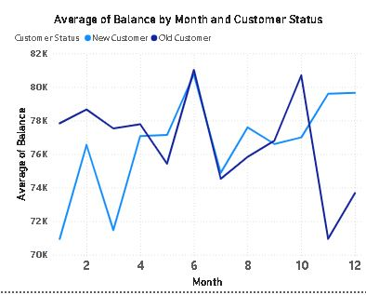

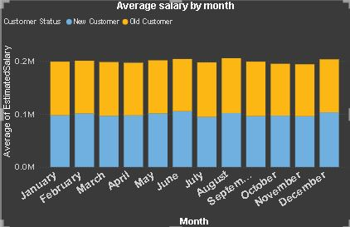

**Location sub -1 page of power bi**

1. Product Affinity Study: Which bank products or services are most commonly used together, and how might this influence cross-selling strategies?

**Answer:**

## **Product Affinity Study for Banks**

A product affinity study can be a powerful tool for banks to understand customer behavior and improve their cross-selling strategies. By analyzing which products and services customers tend to use together, banks can identify opportunities to recommend relevant products that meet their customers' financial needs.

Here's how a product affinity study can be conducted and used for cross-selling:

**Data Collection:**

* **Customer Transaction Data:** Analyze customer account activity to see which products are used together frequently. This includes checking and savings accounts, credit cards, loans, mortgages, investment accounts, etc.
* **Customer Demographics:** Consider factors like age, income, profession, and family status, as these can influence product usage patterns.

**Analysis Techniques:**

* **Market Basket Analysis:** This technique identifies frequently occurring combinations of products within customer transactions.
* **Association Rule Learning:** This method goes beyond simple co-occurrence and determines the strength of the relationship between product pairings.

**Insights and Cross-Selling Strategies:**

* **Identify Product Bundles:** Based on the analysis, create product bundles that combine frequently used products at a discounted rate or with additional benefits.
* **Targeted Recommendations:** Leverage customer data to recommend relevant products to individual customers. For example, a customer with a checking account and a history of using a credit card might be a good candidate for a rewards credit card.
* **Personalized Marketing Campaigns:** Develop targeted marketing campaigns that promote product bundles or specific products based on customer segments with similar product affinity patterns.

**Benefits of Product Affinity Studies:**

* **Increased Sales and Revenue:** Effective cross-selling can lead to increased sales of existing products and services.
* **Improved Customer Satisfaction:** By recommending relevant products, banks can better meet customer needs and enhance their banking experience.
* **Stronger Customer Relationships:** Cross-selling opportunities can strengthen customer relationships and promote long-term loyalty.

**Additional Considerations:**

* **Data Privacy:** Ensure customer data is collected and used in accordance with data privacy regulations.
* **Customer Needs:** Always prioritize customer needs over aggressive sales tactics.
* **Transparency:** Be transparent about product recommendations and avoid pressuring customers into unnecessary purchases.

By conducting a product affinity study and implementing effective cross-selling strategies, banks can gain valuable insights into customer behavior, strengthen relationships, and ultimately achieve sustainable growth.

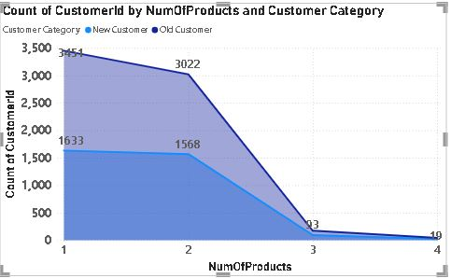

**Location sub -2 page of power bi**

1. Geographic Market Trends: How do economic indicators in different geographic regions correlate with the number of active accounts and customer churn rates?

**Answer:**

Active Category: This category is split into two sections: Active Member and Inactive Member. It likely refers to the user’s engagement status before exiting the platform.

Geographic Location: This section shows three European countries: Germany, France, and Spain.

Sum of Exited: This section shows the total number of exited users for each combination of Active Category and Geographic Location. For instance, the value under Active Member in Germany is 800, which means 800 users who were previously active exited the platform in Germany.

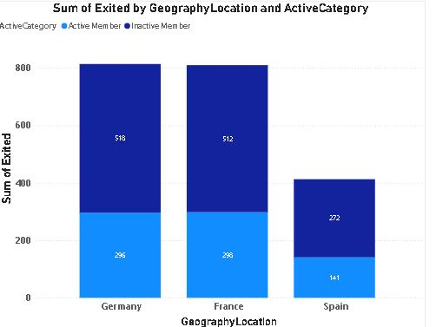

**Location sub -3 page of power bi**

1. Risk Management Assessment: Based on customer profiles, which demographic segments appear to pose the highest financial risk to the bank, and why?

**Answer:**

* The risk management assessment of customers based on customer profiles. It appears to be looking at which demographic segments pose the highest financial risk to the bank. Here's a breakdown of the information in the table:
* Salary Segment: This column shows the salary brackets for the customers. The brackets include Low Salary, Medium Salary, High Salary, and Not Disclosed.
* Credit Score Segment: This column shows the credit score brackets for the customers. The brackets include Poor, Fair, Good, and Excellent.
* Count of CustomerID: This table shows the count of the number of customers in each combination of salary and credit score bracket. For instance, there are 237 customers with a Low Salary and a Poor credit score.

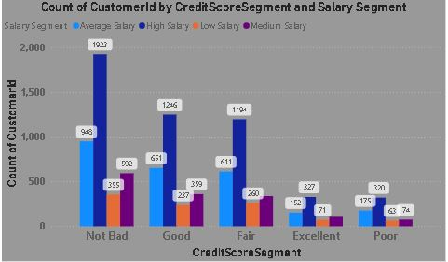

**Location sub -4 page of power bi**

1. Customer Tenure Value Forecast: How would you use the available data to model and predict the lifetime (tenure) value in the bank of different customer segments?

**Answer:**

* High-value segments: Customers with high salary and high balance tend to have the longest tenure (4.88 years on average). This suggests that this segment may be the most valuable to the bank.
* Tenure by wealth: Looking at just the rich category, high balance customers still have a higher tenure than low balance customers (4.97 years vs 436 years). The same pattern holds for middle class and poor classifications.
* Tenure by salary: Within each balance category (high, medium, low) customers with high salary have a longer tenure than those with lower salaries.

**Location sub -5 page of power bi** 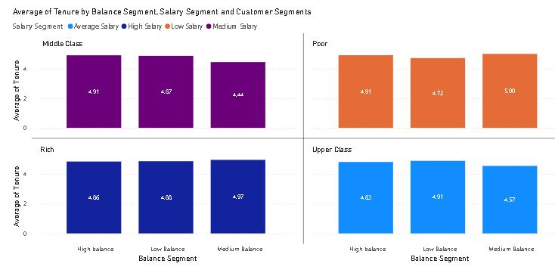

1. Marketing Campaign Effectiveness: How could you assess the impact of marketing campaigns on customer retention and acquisition within the dataset? What extra information would you need to solve this?

**Answer:**

**Metrics and Analysis Techniques:**

* **Customer Acquisition:**
  + **New Customer Acquisition Rate:** Track the number of new customers acquired during and after the campaign period compared to a control group or historical data.
  + **Cost per Acquisition (CAC):** Calculate the cost of acquiring a new customer through the campaign by dividing the total campaign expenditure by the number of new customers acquired.
  + **Campaign Source Tracking:** Use UTM parameters or trackable links to identify which marketing channels (social media, email marketing, etc.) are most effective in driving new customer acquisition.
* **Customer Retention:**
  + **Customer Retention Rate:** Calculate the percentage of existing customers retained during and after the campaign period compared to a control group or historical data.
  + **Churn Rate:** Track the rate at which customers stop using your product or service after the campaign. A decrease in churn rate might indicate a positive impact.
  + **Customer Lifetime Value (CLTV):** Analyze if the campaign influences future customer purchases, potentially increasing CLTV.

**Data Analysis Techniques:**

* **Segmentation:** Segment customer data based on demographics, campaign exposure, and past behavior to identify which groups respond best to specific campaigns.
* **Time Series Analysis:** Analyze customer trends over time to isolate the campaign's impact and account for other potential influencing factors.
* **Statistical Tests:** Conduct A/B testing or other statistical tests to determine if the observed changes in acquisition or retention rates are statistically significant and attributable to the marketing campaign.

**Additional Information Needed:**

* **Campaign Details:** Dates, channels used, budget spent, and messaging of the marketing campaign.
* **Customer Data:** Customer demographics, purchase history, campaign exposure details (impressions, clicks, etc.), and customer churn status.
* **Control Group:** Ideally, a group of customers who were not exposed to the campaign for comparison purposes.
* **Historical Data:** Retention and acquisition rates before the campaign for trend analysis.

**Advanced Techniques:**

* **Marketing Mix Modeling (MMM):** This advanced technique can estimate the individual and combined effects of various marketing activities (including campaigns) on sales and other key metrics. However, MMM requires a larger, more complex dataset and specialized software.

**Benefits of Assessing Campaign Effectiveness:**

* **Identify Successful Strategies:** By understanding which campaigns drive acquisition and retention, you can replicate successful strategies in future campaigns.
* **Optimize Marketing Budget:** Allocate resources more efficiently by focusing on channels and campaigns with the highest return on investment (ROI).
* **Improve Customer Experience:** Campaign effectiveness assessment can help tailor future campaigns to better meet customer needs and preferences.

By utilizing these metrics, analysis techniques, and potentially acquiring additional information, you can gain valuable insights into how marketing campaigns impact customer acquisition and retention. This allows for data-driven decision making in optimizing future marketing efforts for maximum effectiveness.

1. Customer Exit Reasons Exploration: Can you identify common characteristics or trends among customers who have exited that could explain their reasons for leaving?

**Answer:**

* Churn Rate by Balance Segment." The chart shows the churn rate for three different customer balance segments: low, medium, and high. The churn rate is highest for customers with low balances (around 30%) and lowest for customers with high balances (around 10%)
* The chart suggests that banks may lose more customers with low balances. This could be because these customers find it easier to switch banks, or because they are less profitable for the bank to retain

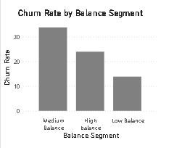

* Churn Rate by Year". The x-axis of the chart lists the years 2016, 2017, 2018, and 2019. The y-axis shows churn rate as a percentage. There is a single data series plotted as a blue bar for each year.
* It appears that churn rate has fluctuated somewhat over the four years. In 2016, the churn rate was around 10%. It then appears to have increased in 2017 to around 15% and then decreased again in 2018 to around 10%. In 2019, it appears to have increased slightly to around 12%.

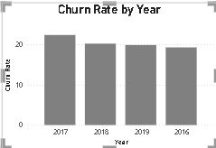

* Churn Rate by NumOfProducts." The x-axis of the chart shows the number of products a customer has (0, 1, 2, 3, 4) and the y-axis shows churn rate as a percentage.
* Churn rate and number of products: The churn rate appears to be inversely proportional to the number of products a customer has. Customers with no products have the highest churn rate (around 50%), while customers with four products have the lowest churn rate (around 10%).

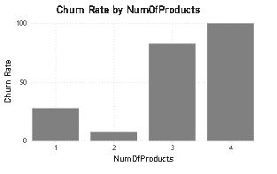

* The x-axis shows the credit score segment, which ranges from "Poor" to "Excellent." The y-axis shows the churn rate, though it is labeled "Chum Rate."
* Churn rate by credit score: The churn rate appears to be lower for customers with higher credit scores. For example, the churn rate for customers with poor credit scores is around 30%, whereas the churn rate for customers with excellent credit scores is around 10%. This suggests that customers with better credit scores are more valuable to the bank and the bank may want to focus its retention efforts on these customers.

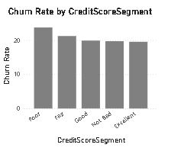

* The old customer category has the highest count of salary segments, while the new customer category has the lowest count of salary segments.
* Distribution of salary segments: It is difficult to say anything about the distribution of salary segments within each customer category because we are only looking at the total count for each category.
* New vs Old Customers: There are many more old customers than new customers. This doesn't necessarily mean that churn rate is low, it could just mean that the bank has been around for a long time and has accumulated a large base of old customers.

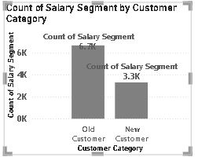

* Churn Rate by Salary Segment." The chart shows the churn rate for four different customer salary segments: low, medium, low-medium, and high-medium. The churn rate is highest for customers with low salaries (around 35%) and lowest for customers with high-medium salaries (around 15%).
* Customer value and churn: The chart suggests that banks may lose more customers with low salaries. This could be because these customers are more price-sensitive or because they find it easier to switch banks.
* Reasons for churn: The chart doesn't tell us why customers are churning. It could be due to factors like fees, interest rates, lack of features, or poor customer service.

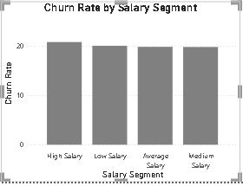

**Location sub -7 page of power bi**

1. Are 'Tenure', 'NumOfProducts', 'IsActiveMember', and 'EstimatedSalary' important for predicting if a customer will leave the bank?

* **Tenure**: The number of years that the customer has been a client of the bank can be a significant factor. Normally, older clients are more loyal and less likely to leave a bank1.
* **NumOfProducts**: The number of products a customer has with the bank could potentially influence their decision to stay or leave. Customers with multiple products might have a higher level of engagement with the bank, which could reduce the likelihood of churn2.
* **IsActiveMember**: Whether a customer is active or not can be a strong predictor of churn. Active customers are likely to be more engaged with the bank’s services, and therefore, may be less likely to churn2.
* **EstimatedSalary**: While one might assume that a customer’s estimated salary could influence their likelihood to churn, it has been found that estimated salary showed little to no correlation with churn3. This could be due to a variety of factors, such as the customer’s satisfaction with the bank’s services, which might not necessarily be tied to their income3.
* Remember, these are general trends and may not apply to every customer. A comprehensive analysis should be conducted using appropriate statistical and machine learning techniques to determine the significance of these factors in predicting customer churn4. It’s also important to note that the importance of these factors can vary depending on the specific context and customer base of the bank
* Total customer by Num of Products and Exited." The x-axis shows the number of products a customer has (0, 1, 2, 3, 4+) and the y-axis shows the total number of customers. There is a blue bar for exited customers and an orange bar for total customers.
* Customer product usage: The number of customers seems to decrease as the number of products they use increases. There are many customers with zero products (around 6,000) and far fewer customers with four or more products (around 600).
* Churn rate by product usage: It appears that customers who use more products are less likely to churn. The blue bar (exited customers) is much higher for customers with zero products than for customers with four or more products. This suggests that banks can reduce churn by encouraging customers to use more products.

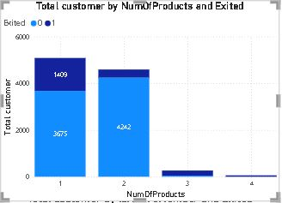

* Customer churn over time: A higher percentage of customers seem to churn in the first year (around 3000 customers) compared to later years. The number of exited customers seems to level off after a few years. This suggests that the bank may be losing a significant number of customers early on in the relationship.
* Long-term customers: The chart shows that the bank has a good number of long-term customers (those who have been with the bank for more than 4 years). There are around 1990 customers who have been with the bank for 5 years and around 1072 customers who have been with the bank for more than 9 years.

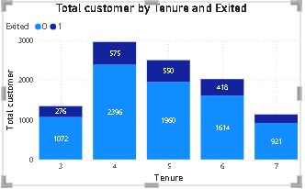

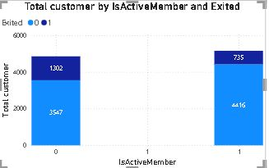

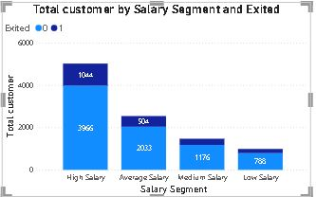

**Location sub -8 page of power bi**

1. Utilize SQL queries to segment customers based on demographics and account details.

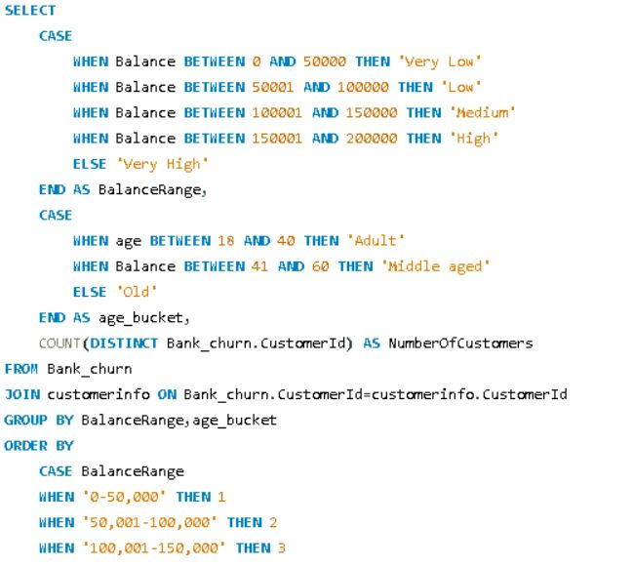

C:\Users\ncr\Pictures\SQL SUbjective 9th 2nd part.JPG

**Here are some of the insights we can glean from this data:**

* **Customer Distribution by Age**: The table shows that there are more adult customers (2401 + 944 + 593 + 22 = 3960) than older customers (1429 + 565 + 342 + 12 = 2348) across all budget ranges.
* **Customer Distribution by Budget**: The table shows that the greatest number of customers fall under the "Very Low" budget range (2459), followed by "Medium" (2401), "Low" (1509), "High" (935) and "Very High" (34).

**Conclusion**

* The query effectively segments the customers based on their balance and age, providing valuable insights into the demographic distribution of account balances. This analysis can help the bank tailor its marketing strategies and financial products to different customer segments, focusing on the needs of low and medium balance holders while exploring opportunities to attract and retain high and very high balance customers.

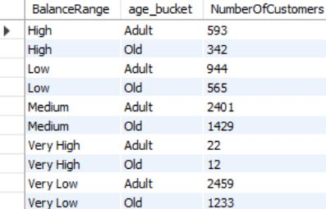

1. How can we create a conditional formatting setup to visually highlight customers at risk of churn and to evaluate the impact of credit card rewards on customer retention?

* The table shows customer segments and their average salary. However, the average salary is not explicitly listed in the table itself.
* The table contains headers for "Customerld", "Sum of Num Of Products", "Customer Segments" and "Salary Segment".
* There are multiple entries with different customer IDs, none of which contain values.
* The table shows different customer segments including "Upper Class", "Rich", "Middle Class" and "Poor".

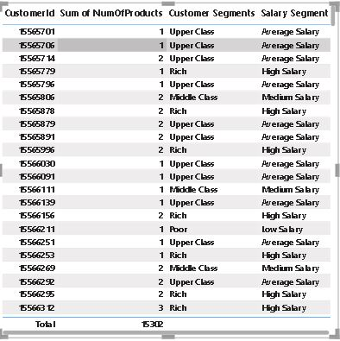

1. What is the current churn rate per year and overall as well in the bank? Can you suggest some insights to the bank about which kind of customers are more likely to churn and what different strategies can be used to decrease the churn rate?

**Answer:**

This analyzes customer churn rates and identifies segments most susceptible to churn. It also proposes strategies to decrease churn and improve customer retention.

**Churn Rate**:

* The overall churn rate for the bank is 20.37%.
* Year-on-year churn rates show some fluctuations:
  + 2016: 19.27%
  + 2017: 22.35% (highest)
  + 2018: 20.21%
  + 2019: 19.86% (lowest)
  + Customer Segments Prone to Churn:
  + Data analysis suggests a customer segment with a higher likelihood of churn:
* Purchases 1 product: Customers who only use one  product by bank  might not find enough value compared to competitors offering wider ranges or integrated services.
* Has credit card: Potential reasons for churn among credit card holders could be:
  + Limited credit limits not meeting their needs.
  + Lack of rewards programs that incentivize them to keep the card.
  + High credit card fees.
* Tenure of 4-5 years: Customers with this tenure might be nearing the end of introductory offers or discounts, making them susceptible to competitor offers with better rates or features.
* High salary: High earners might have more options and be more likely to switch for a slightly better interest rate or benefit elsewhere.

**Recommendations to Reduce Churn**:

* Targeted Product Bundles: Create product bundles that cater to specific customer segments and needs. Offer these bundles to customers who only use one product, highlighting the additional benefits and potential cost savings.
* Enhanced Credit Card Rewards: Improve credit card rewards programs for existing customers. This could involve:
  + Increasing credit limits based on customer history and creditworthiness.
  + Offering rewards programs aligned with spending habits (e.g., travel rewards, cash back for specific categories).
  + Reducing or eliminating annual fees, especially for high-value customers.
* Retention Offers for Existing Customers: Proactively reach out to customers nearing the end of introductory offers with personalized retention deals. This could include extending introductory rates or offering discounts on other products or services.
* Customer Satisfaction Surveys: Regularly conduct customer satisfaction surveys to understand why customers churn. This can help identify areas for improvement and tailor retention strategies accordingly.
  + Relationship Management for High-Value Customers: Develop dedicated relationship managers for high-value customers to provide personalized service, address their specific needs, and offer exclusive benefits
* Churn rate is typically highest in a company's early years, as it takes time to acquire and retain customers.
* Churn rate can be seasonal, with higher rates in certain months or quarters.
* Churn rate can vary by industry, with some industries having naturally higher churn rates than others.

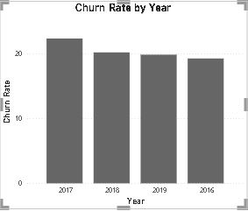

**Location sub -11 page of power bi**

1. Create a dashboard incorporating all the KPIs and visualization-related metrics. Use a slicer in order to assist in selection in the dashboard.

**Dashboard**

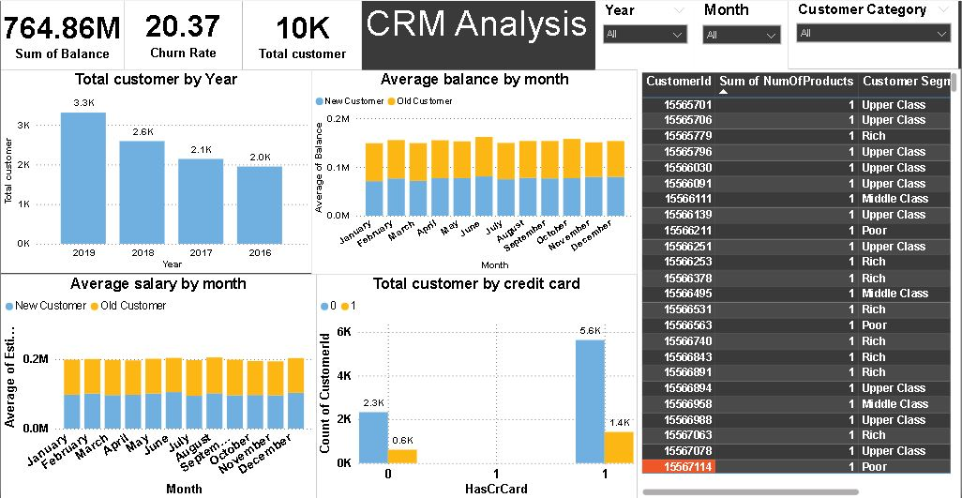

**Dashboard**

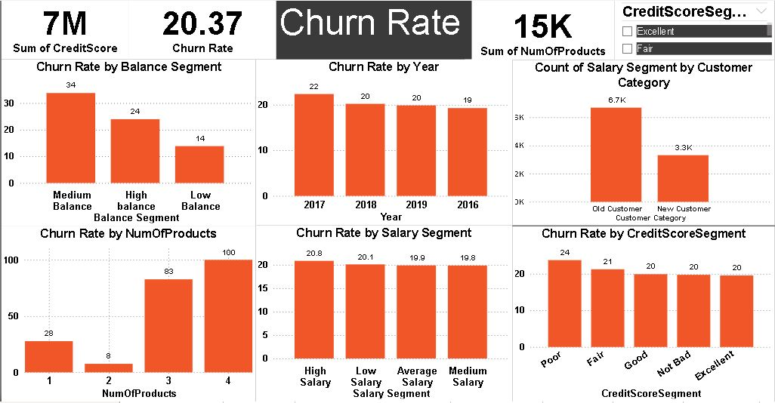

**Dashboard**

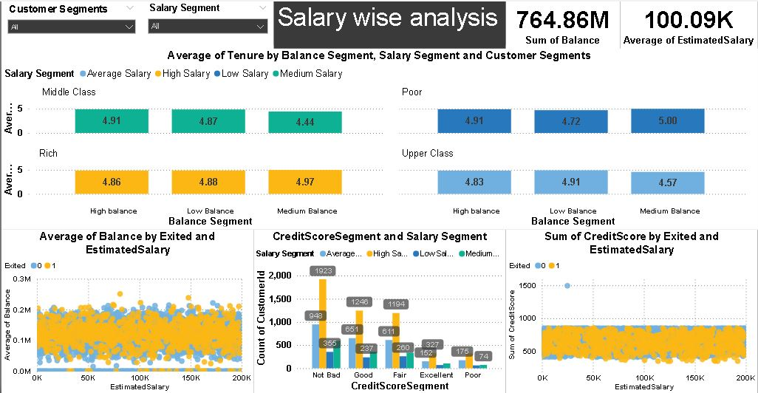

1. How would you approach this problem, if the objective and subjective questions weren't given?

Answer:

If I were faced with a problem where both the objective and subjective questions were not given, I would take a systematic approach to address it:

1. **Define the problem**: Clearly understand what the problem is, what is being asked, and what the constraints are. This might involve breaking down the problem into smaller, more manageable parts.
2. **Gather information**: Collect any relevant data or information that might help in understanding the problem better. This could involve researching similar problems, consulting experts, or conducting experiments if applicable.
3. **Analyze the problem**: Once I have a clear understanding of the problem and relevant information, I would analyze it to identify any patterns, trends, or relationships that could be useful in finding a solution.
4. **Generate possible solutions**: Brainstorm different approaches or solutions to the problem based on the analysis. This might involve considering both traditional and unconventional methods.
5. **Evaluate solutions**: Assess the potential effectiveness of each solution by considering factors such as feasibility, cost, time required, and potential risks or drawbacks.
6. **Select the best solution**: Based on the evaluation, choose the solution that seems most promising or appropriate given the constraints of the problem.
7. **Implement the solution**: Develop a plan to put the chosen solution into action. This might involve further refinement or adjustment based on practical considerations.
8. **Monitor and adjust**: Once the solution is implemented, continuously monitor its effectiveness and be prepared to make adjustments as necessary based on feedback or changing circumstances.
9. In the “Bank_Churn” table how can you modify the name of the “HasCrCard” column to “Has_creditcard”?

**ALTER TABLE bank_churn**

**RENAME COLUMN HasCrCard TO Has_creditcard**;

**Conclusion**

This project aimed to analyze various customer-related datasets provided by a bank to gain insights into customer churn, improve service delivery, and enhance customer satisfaction. By examining factors like demographics, transaction details, customer exit information, and active customer profiles, we were able to uncover valuable information.

Our analysis revealed key factors contributing to customer churn, including credit score, account balance, and product usage. We identified profitable customer segments and explored potential reasons for customer exits. Additionally, we investigated the relationship between various customer attributes and churn rates. The findings from this project can be used by the bank to develop targeted strategies to reduce churn, retain valuable customers, and optimize product offerings. Here are some specific recommendations:

● Develop targeted marketing campaigns for customer segments identified as High churn risk.

● Offer incentives like credit cards or loyalty programs to encourage product Usage and increase customer engagement.

● Investigate reasons behind customer exits and address areas where the bank can improve its services.

● continuously monitor customer behavior and churn rates to refine strategies over time.

This project provided a valuable starting point for understanding customer behavior and churn. Further analysis can be conducted to delve deeper into specific areas, such as product affinity and customer lifetime value. By using the insights gained from data analysis, the bank can develop data-driven strategies to improve customer relationships and achieve its business goals.